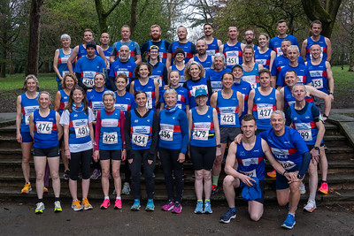

2024

Preston Harriers road championship

:

Championship 2023

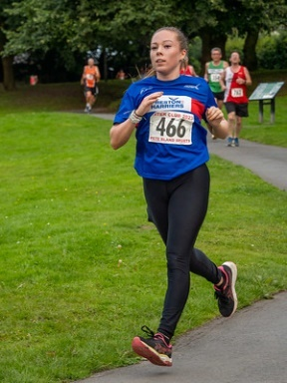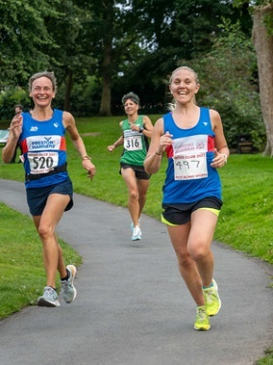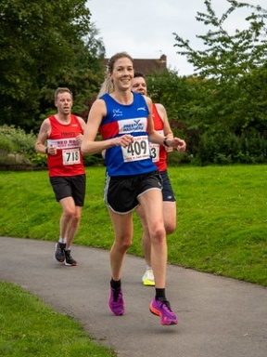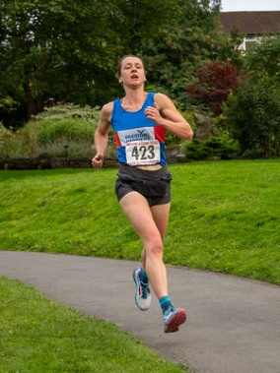
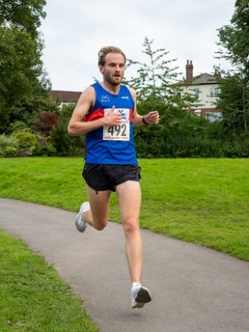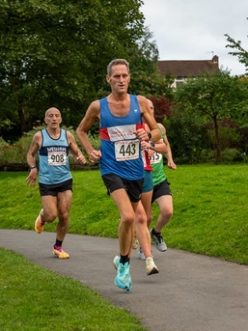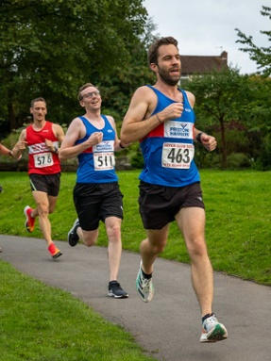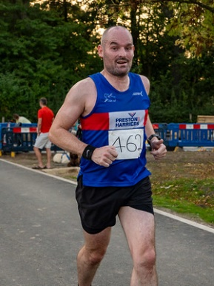
Preston Harriers at Interclub
2023 saw the latest edition of the club championship with Sam Evans and Cathy Flitcroft once again being crowned king and queen of the roads.
The 2024 format follows the same pattern as the 2023 championships.
Races included offer the usual mix of fast competitive, hilly challenging and small local events to allow runners to plot their way to success by playing to their individual strengths. There are 15 races in the championship with runners needing to run one race under each of the 5k, 10k, and 10 mile categories and three interclub races (excluding Preston) to achieve an overall league finish, potentially getting their hands on a trophy and place in harriers’ history.
Age category titles are also up for grabs for vet-40, vet-50 and vet-60+ runners, with vet-60 runners not required to run the 10-mile distance in order to win their category.

Prizes and points scoring

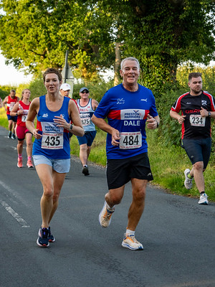
Heidi and Dale Wallis at the Wesham Inter Club 2023

In the open male and female categories prizes will be awards to the top three scoring runners, who have completed the required number of races, whilst in the vet-40, vet-50 and vet-60+ categories only the highest scoring runner will receive a prize.
The following points scoring system will be used; 1st 52pts, 2nd 50pts, 3rd 48pts, 4th 47pts, to 50th & below 1pt.
In the event of an end of season tie, the winner, will be determined by whoever has scored the most points, across their best three interclub races. Should this still result in a tie, then the winner will be the runner with the lowest total time across their seven highest scoring performances.

Fixtures calendar
 |  | January | February | March | April | May | June | July | August | September
5k | 1 to count |  |  | Wigan Festival 5k 17th |  | Lancaster Power of 5k 3rd |  |  | Mid Cheshire 23rd
Interclub | 3 to count |  |  |  | Blackpool 10th | Lytham 9th | Thornton 25th | Wesham 22nd | Chorley 14th | Red Rose 4th
10k | 1 to count |  | Hale 10k 18th | New Longton 10k 3rd |  |  | Catforth 10k 23rd
10 mile | 1 to count | Morecambe 10 mile 21st |  | Caldervale 10 mile 29th |  |  |  |  |  | Riverside Lancaster 10 mile 1st

Notable other fixtures during this period:
CROSS COUNTRY
County Champs – 6th Jan
Mid Lancs – 13th Jan
Mid Lancs – 10th Feb
Northern Champs – 27th Jan
ROAD RELAYS
6/12 stage – 23rd March
Northern – 6th April
TRACK AND FIELD
Lancs Champs – 11-12 May
Northern League – 18th May
Northern League – 15th June
Northern League – 14th July
Northern League – 17th Aug
FELL RELAYS
Calderdale Relays – 18/19 May

5k

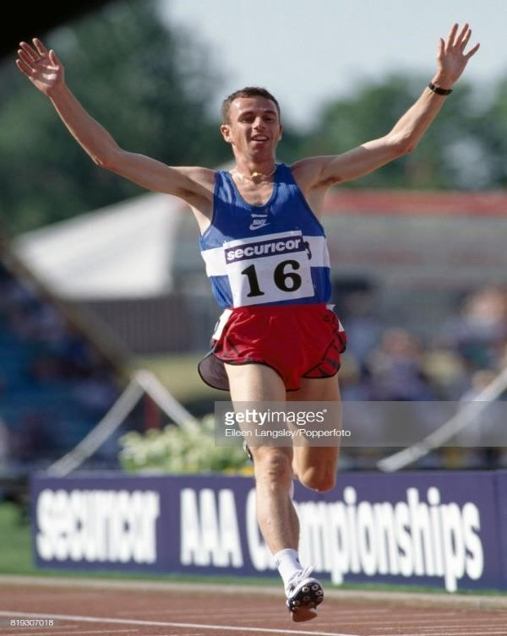
The 5k race is the road equivalent of the 5000 metres and the shortest of the common long distance races. It is a great place to start road racing and free weekly 5k parkruns are available across the globe for those wishing to learn the distance.
The club road records are 13:42 for men, set by John Nuttall in 1995 and 15:45 for women, set by Helen Clitheroe in 2010.

John Nuttall of Great Britain celebrates winning the men's 5000 metres competition during the AAA Championships in Birmingham, circa 1996. (Photo by Eileen Langsley/Popperfoto/Getty Images)

Wigan 5k | Part of Wigan Festival of Running – out and back course | March 17th
Lancaster, Power of 5k | Fast 3 Laps, no tight corners, no road crossings. | May 3rd

Mid Cheshire 5k | Fast course, competitive race | August 23rd

10k

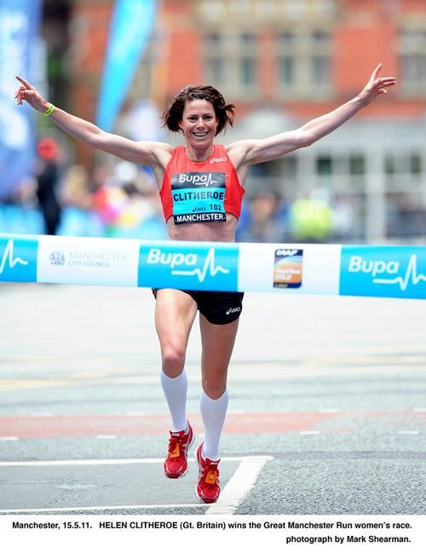
The 10k is the road equivalent of the 10,000 meters. It is a very popular distance and most weekends you will find a race to do somewhere. The harrier's men’s record currently stands at 29:24 and was set by Patrick Dever in 2018. While the women’s record stands at 31:45 and is held by Helen Clitheroe since 2011.

Helen Clitheroe winning the women’s Great Manchester 10k 2011, Photo by Mark Shearman

Hale 10k | Run on closed roads. Starts in Hale before heading out on country lanes. Great early season race. | Feb 18th
New Longton 10k | Local race along country lanes with a slight incline in the second half | March 3rd
Catforth 10k | 2 laps on country roads, great local race | June 23rd

The 10 mile
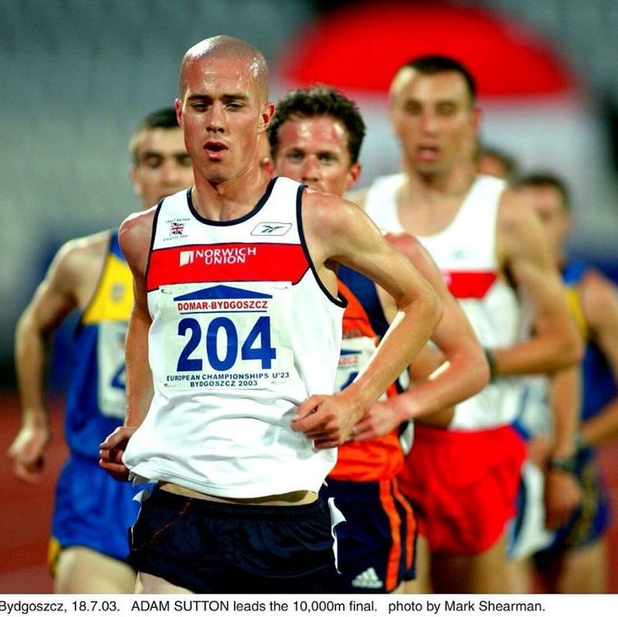
The 10 mile is a classic race distance, that is often overlooked by many runners and is perhaps not as popular as it should be. It is the ideal distance for those looking to move up to the half marathon from the 10k and those working on improving their time over the half.
Harriers men’s record is 48:05 set by Adam Sutton in 2006, whilst the women’s record currently stands at 58:18 and has been held by Helen Clitheroe since 2015.

Adam Sutton competing for team GB in the 10,000 at the 2003 U23 European
championships. Photo by Mark Shearman.

Morecambe 10 miler | Out and back course from the café to Morecambe prom and back | Jan 21st
Caldervale Good Friday  10 miler | Hilly challenging course | March 29th
Riverside 10 miler | Flat and fast | September 1st

In addition to the road championship series, the club also has a 10 mile championship race incorporated into the Preston 10 mile, held each November since 1982.

Interclub
The Interclub road races series is where Preston Harriers competes against six clubs from the mid-Lancashire area over distances between 4 and 5 miles. For the road championship, all runners must complete at least three interclub races, excluding the Preston Harriers hosted event.
The road championship qualifying fixtures for 2024 are as follows;
- Blackpool April 10th
- Lytham May 9th
- Thornton June 25th
- Wesham July 22nd
- Chorley August 14th
- Red Rose September 4th

2023 saw Preston take the Ladies Open team prize with an outstanding squad performance, their last win in this category being in 2012!
In addition the Vets Over 40 and Over 50 also took the relevant team prizes!

Year | Mens Open | Ladies Open | Male vet 40 | Ladies F40 | Vet 50 | Vet 60
2023 | BWFAC | Preston | Preston | BWFAC | Preston | Red Rose
2022 | BWFAC | Lytham | BWFAC | Lytham | Preston | Red Rose
2019 | Preston | Lytham | Preston | BWFAC | Preston | Red Rose
2018 | Preston | Lytham | Preston | Lytham | Preston | Wesham
2017 | Preston | Lytham | Wesham | Preston | Red Rose | Red Rose
2016 | Preston | Wesham | Wesham | Preston | Red Rose | Red Rose
2015 | Preston | BWFAC | Preston | - | Red Rose | BWFAC
2014 | Preston | BWFAC | Preston | - | Preston | Wesham
2013 | Preston | Wesham | Preston | - | Preston | Wesham
2012 | Preston | Preston | Preston | - | Wesham | Wesham
2011 | Preston | BWFAC | Preston | - | Wesham | Wesham
2010 | Preston | BWFAC | Preston | - | Wesham | Wesham
2009 | Preston | BWFAC | Preston | - | Wesham | Red Rose
2008 | Preston | BWFAC | Preston | - | Wesham | BWFAC
2007 | BWFAC | BWFAC | BWFAC | - | Wesham | BWFAC
2006 | Preston | Preston | North Fylde | - | Wesham | Wesham
2005 | North Fylde | North Fylde | North Fylde | - | Wesham | -
2004 | Wesham | North Fylde | Wesham | - | - | -
2003 | North Fylde | BWFAC | North Fylde | - | - | -
2002 | Preston | Preston | North Fylde | - | - | -
2001 | North Fylde | North Fylde | North Fylde | - | - | -
2000 | North Fylde | North Fylde | North Fylde | - | - | -

Hall of fame
The men’s open championship

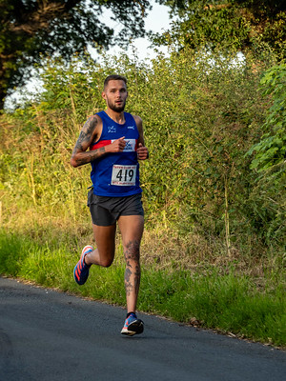
The current men’s open launched in 1985 and has been won by 19 difference athletes, Geoff Orritt holds the records for the most wins (5) and longest winning streak (4 years).
1985 Simon Harris | 1998 David Simpson | 2013 Rob Affleck
1987 Geoff Orritt | 1999 Stephen Clayton | 2014 Rob Affleck
1988 B Brown | 2000 Stephen Clayton | 2015 Gethin Butler
1989 Geoff Orritt | 2001 Colin Shuttleworth | 2016 Richard Smith
1990 Geoff Orritt | 2002 Stephen Clayton | 2017 Simon Collins
1991 Geoff Orritt | 2006 Adam Sutton | 2018 Karl Hodgson
1992 Geoff Orritt | 2007 Steve Hallas | 2019 Simon Collins
1993 Mark Crook | 2008 Gethin Butler | 2022 Sam Evans
1994 Alan Metcalf | 2009 Steve Hallas | 2023 Sam Evans
1995 Michael Simon | 2010 Garry Pennington
1996 Steve Smith | 2011 Gethin Butler
1997 Alan Appleby | 2012 Rob Affleck

The women’s open championship
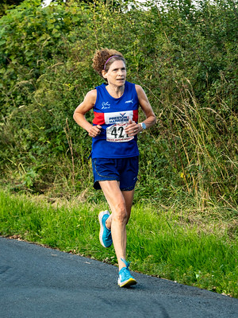
2023 champion Cathy Flitcroft
The women’s open championship has been won by 13 different athletes, with Philippa Walsh and Dorothy Parks sharing the record for the most wins (5) and Dorothy holding the record for longest winning streak (3).
1996 Philippa Walsh | 2009 Liz Abbott | 2022 Cathy Flitcroft
1998 Anne Sweeney | 2010 Gema Admas | 2023 Cathy Flitcroft
1999 Philippa Walsh | 2011 Emma Essex-Crosby
2000 Jill Beswick | 2012 Meanie Hawoth
2001 Philippa Walsh | 2013 Carol Spoor
2002 Alison Crook | 2014 Marian Hesketh
2003 Philippa Walsh | 2015 Dorothy Parkes
2004 Philippa Walsh | 2016 Dorothy Parkes
2006 Anne Sweeney | 2017 Dorothy Parkes
2007 Dorothy Capstick (now Parkes) | 2018 Jade Bebbington
2008 Dorothy Capstick (now Parkes) | 2019 Emma Essex-Crosby

Vet- 40 championships
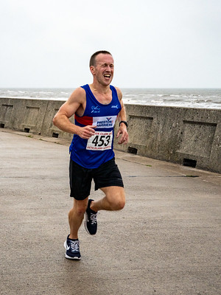
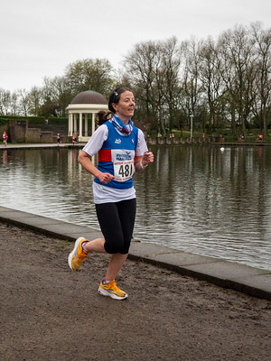

2023 winners Julie Tyrer and Stuart Nixon
For male and female vet-40 category can be a competitive one, with the different titles changing several times. Rob Affleck and Andy Whaley are the most successful male athletes in this category with 3 wins each, whilst Julie Tyrer is the most successful female athlete with 4 wins.

Male role of honour |  |  | Female role of honour
2006 | Alan Metcalfe |  | 2007 | Anne Sweeney
2007 | David Barker |  | 2008 | Anne Sweeney
2008 | Dave Watson |  | 2009 | Sue Wickham
2009 | Mark Lee |  | 2010 | Beverley Mackay
2010 | Gary Pennington |  | 2011 | Beverley Mackay
2011 | Gethin Butler |  | 2012 | Susan Clemson
2012 | Rob Affleck |  | 2014 | Vicky Sherrington
2013 | Rob Affleck |  | 2015 | Helen Boyer
2014 | Rob Affleck |  | 2016 | Kari Edwards
2015 | Gethin Butler |  | 2017 | Julie Tyrer
2016 | Andrew Tranter |  | 2018 | Vicky Sherrington
2018 | Andy Whaley |  | 2019 | Julie Tyrer
2019 | Andy Whaley |  | 2022 | Julie Tyrer
2022  2023 | Andy Whaley  Stuart Nixon |  | 2023 | Julie Tyrer
Vet- 50 championships
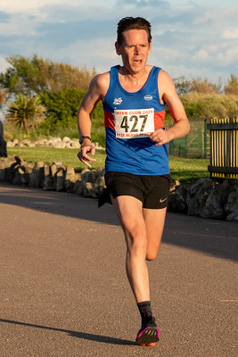
2023 winners Steve Hallas and Cathy Flitcroft
Sue Wickham has dominated the women’s vet-50 category with five back-to-back wins between 2014 and 2018. In male category its Peter Cowling who has been the standout performer with four back-to-back wins between 2014 and 2017. With Steve Hallas being new to this age category can he challenge Peters performance in the years to come?
Male role of honour |  |  |  | Female role of honour
2007 | Alan Appleby |  |  | 2011 | Anne Sweeney
2008 | Phil Lakeland |  |  | 2012 | Philippa Walsh
2009 | Kevin Hesketh |  |  | 2014 | Sue Wickham
2011 | Alan Metcalfe |  |  | 2015 | Sue Wickham
2012 | Alan Metcalfe |  |  | 2016 | Sue Wickham
2013 | Alan Metcalfe |  |  | 2017 | Sue Wickham
2014 | Peter Cowling |  |  | 2018 | Sue Wickham
2015 | Peter Cowling |  |  | 2019 | Susan Ashcroft
2016 | Peter Cowling |  |  | 2022 | Cathy Flitcroft
2017 | Peter Cowling |  |  | 2023 | Cathy Flitcroft
2018 | Neil McDonald
2019  2022  2023 | Neil McDonald  Dave Watson  Steve Hallas

Vet-60 championships
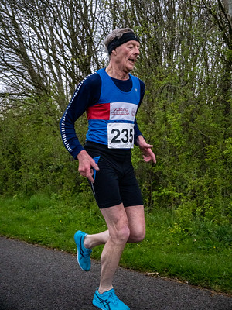
2023 winner Kevin Hesketh
Judith Deakin has dominated the women’s the women’s vet-60 category with six championship wins, including a five-year winning streak between 2008 and 2012. In the male category, Alan Appleby has been champion three times.

Male role of honour |  |  |  | Female role of honour
2008 | Alan Appleby |  |  | 2008 | Judith Deakin
2010 | Dave Roberts |  |  | 2009 | Judith Deakin
2011 | Alan Appleby |  |  | 2010 | Judith Deakin
2016 | Alan Appleby |  |  | 2011 | Judith Deakin
2019 | Alan Appleby |  |  | 2012 | Judith Deakin
2023 | Kevin Hesketh |  |  | 2014  2016  2018  2019  2022 | Marian Hesketh  Judith Deakin  Maureen Kirby  Maureen Kirby  Marian Hesketh

